Assignment 8

Suryavanshi Virendrasingh (B16037)

**Cache Simulator**

Cache simulator is written in C++ which gives number of hits and miss ratio for the given address file. The simulator gives the ratio for cache implemented with Direct Mapping function and 2-way set associative function with LRU and FIFO as replacement algorithms.

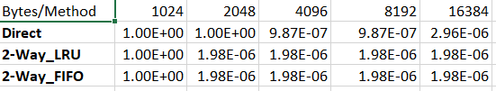

The above table displays the hit rate for the different mapping with different replacement algorithms for the given address file. But it can be seen that for the given address file it is not easy to come to any conclusion. So that’s why I have also use my own created address file to get a clear observation.



So from the second table it can be clearly seen that 2-Way LRU method is ahead of the Direct method and 2-way FIFO method. This is because 2-Way set associative method is a moderation between direct and associative mapping which is complemented by LRU as replacement algorithm which is surely a logical choice over FIFO method.

**Cache Details of my Laptop**

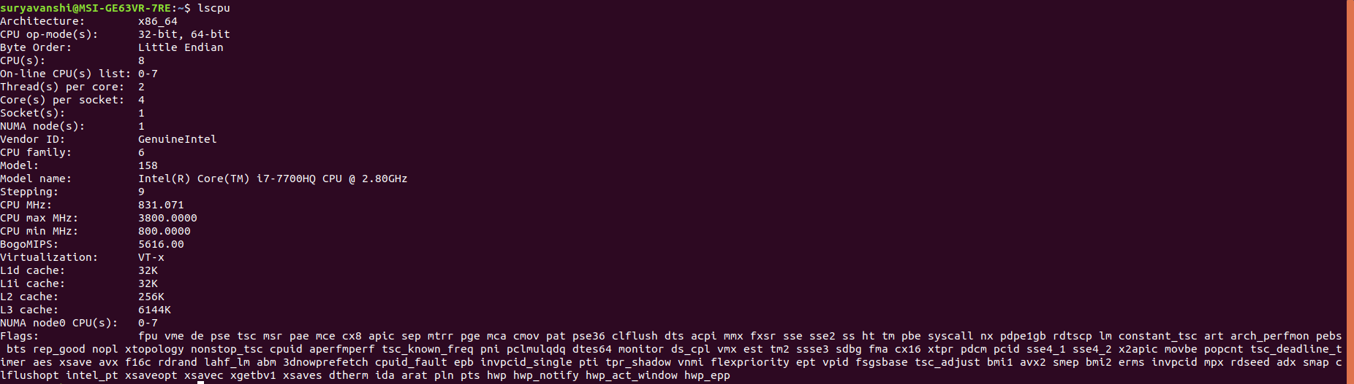

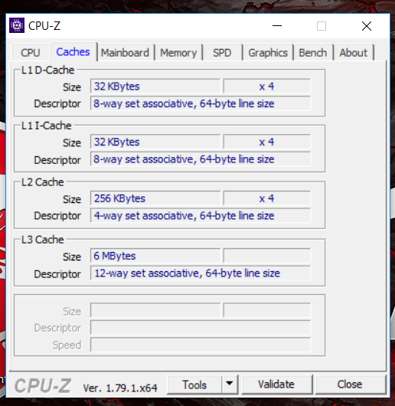

|  |  |  |
| --- | --- | --- |
| Details/Cache | Size (in KB) | Type |
| L1-D | 128 | 8-way set associative |
| L1-I | 128 | 8-way set associative |
| L2 | 1024 | 4-way set associative |
| L3 | 6144 | 12-way set associative |